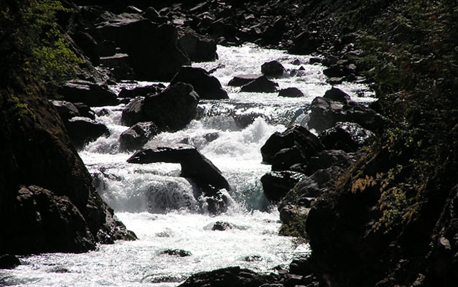
Elwha River Restoration
River Flows and Sediment Movement
Vocabulary Notes

V-shaped valley:

Terrace/bench:

Rapids:

Waterfall:

Kolk:

Plucking:

Gorge:

VOCABULARY TERMS:

- V-shaped valley: A steep valley carved by a fast-flowing river that takes on a shape that resembles a V.

- Terrace/bench: A generally flat area elevated above a river, which at one time was the former riverbed, before the river eroded deeper into the basin.

- Rapids: A sudden change in gradient, particularly over erosion-resistant materials, will cause the river to become turbulent and the velocity increases.

- Waterfall: A cascade of falling water where there is a vertical or almost vertical step in a river.

- Kolk: A vortex in a fast-flowing river, which plucks river bed material, forming a depression in the rock and often a pool or pond.

- Plucking: The removal of stones from a riverbed or bedrock by the erosional force of moving water.

- Gorge: A deep, narrow section of a river caused by erosion into the bedrock.

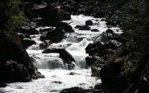
Elwha River Restoration
River Flows and Sediment Movement
Reflection Journal 1
Try to remember what you’ve learned about erosion in other science classes then write down what you know already know about erosion.

What questions do you have about erosion?

Elwha River Restoration
River Flows and Sediment Movement
Reflection Journal 2

Where have you seen V-shaped valleys? What other landforms have you seen that might have been formed by the erosional force of fast-moving water?

What new questions do you have about river flows and sediment movement?

